Lateral View of the Skull Labeling Activity

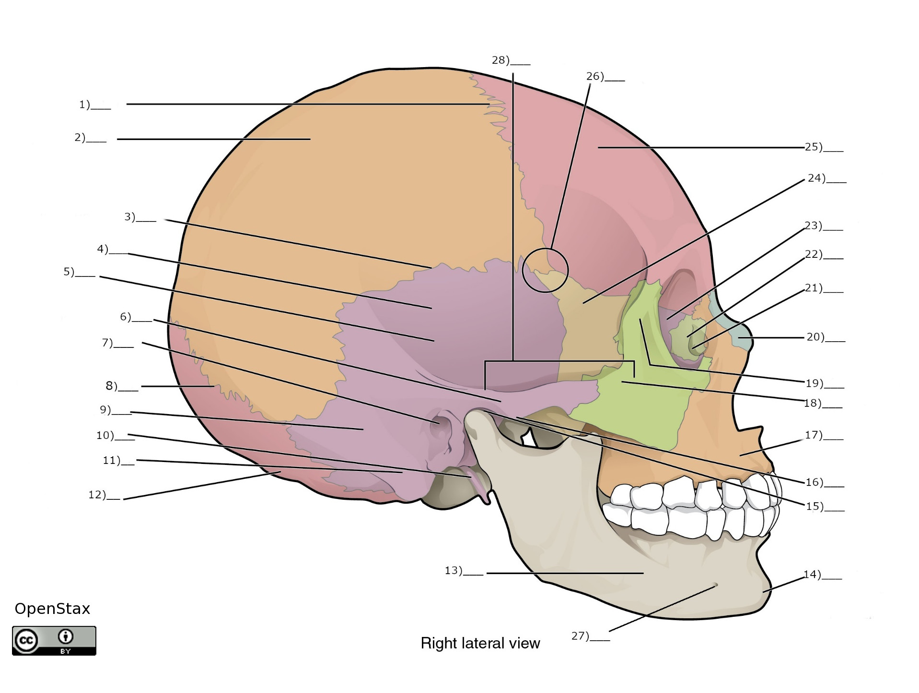

**Word Bank**

1. Lambdoid suture
2. Maxilla
3. Nasal bone
4. Ethmoid bone
5. Lacrimal fossa
6. External Acoustic Meatus
7. Lacrimal bone
8. Occipital bone
9. Pterion
10. Mandible
11. Parietal bone
12. Mental foramen
13. Squamous suture
14. Temporal bone
15. Mandibular fossa
16. Frontal bone
17. Mastoid portion
18. Articular tubercle
19. Coronal suture
20. Styloid process
21. Temporal process
22. Squamous temporal
23. Greater wing of the sphenoid bone
24. Zygomatic Arch
25. Zygomatic bone
26. Mastoid process
27. Mental protuberance of mandible
28. Zygomatic process

**Answer Key**

1. Coronal suture
2. Parietal bone
3. Squamous suture
4. Temporal bone
5. Squamous temporal
6. Zygomatic process
7. External Acoustic Meatus
8. Lambdoid suture
9. Mastoid portion
10. Styloid process
11. Mastoid process
12. Occipital bone
13. Mandible
14. Mental protuberance of mandible
15. Mandibular fossa
16. Articular tubercle
17. Maxilla
18. Temporal process
19. Zygomatic bone
20. Nasal bone
21. Lacrimal fossa
22. Lacrimal bone
23. Ethmoid bone
24. Greater wing of the sphenoid bone
25. Frontal bone
26. Pterion
27. Mental foramen
28. Zygomatic Arch